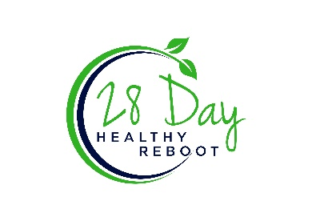

Donna’s Bar Recipes

Donna is a long-time friend and participant in the Healthy Reboot programs. As a Canadian resident, it is sometimes hard to find clean bars to purchase. She has found these two recipes to make her own bars – enjoy!

**Simple Nut Bar Recipe**

Ingredients

4-5 cps mixed nuts and seeds (pecans, blanched almonds, walnuts, pumpkin seeds, sunflower seeds, hemp hearts, macadamia, pistachio, etc.)

1/3 cup coconut oil

2 Tbls of nut butter (your choice)

1/8 cup of organic honey

Directions

Mix all ingredients well in a bowl. Press into a stainless steel or Pyrex pan and chill. Cut into bars and store in an airtight container in fridge or freezer. These bars will melt in the heat.

**Cookie Dough Bars**

**Ingredients**

2 Cups Hemp Hearts (finely ground), Almond Flour or Tiger Nut flour

1 – 2 scoops of protein powder – vanilla or chocolate

¼ cup almond butter

¼ cup maple syrup

1 tsp vanilla

¼ tsp salt

½ tsp almond, coconut, or hemp milk

¼ cup of chocolate chips (unsweetened or sweetened with stevia or monk fruit)

**Topping**

¼ cup of chocolate chips (unsweetened or sweetened with stevia or monk fruit)

1 tsp coconut oil

**Directions**

Add flour choice, protein powder almond butter, maple syrup, vanilla, and salt into a mixing bowl. Slowly add in milk and blend until a thick dough ball forms. Line a loaf pan with parchment paper. Press dough into bottom to form an even layer of dough. Place in freezer while you make the topping.

To make the topping use a double boiler (pan in a pot filled with water) to melt the coconut oil and the chocolate chips together. When melted and well blended, pour over dough. Place in the fridge for 12 hours or overnight.

Cut and enjoy!